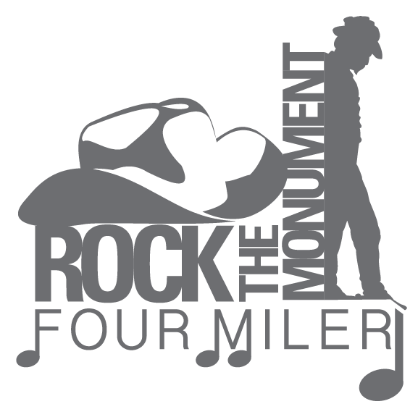
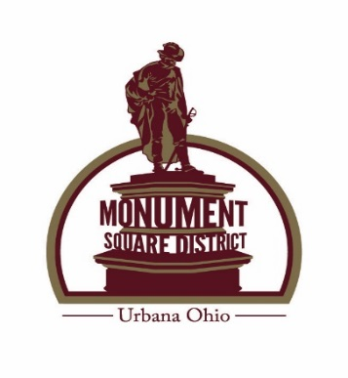
Rock the Monument Four Miler
Four Miler Run/Walk
Friday, June 8, 2018 7:00 p.m.
Melvin Miller Park
Monument Square District Event
Sponsors:
Security National Bank, MartinBrowne Hull & Harper P.L.L, Memorial Health, Peoples Savings Bank, C T Communications, Streamline Design & Print, Willman Furniture Store, Steve’s Market, Champaign Health District, Lotus Yoga & Sertell Chiropractic Clinic
$20.00 pre-register by June 1, 2018 includes entry and t-shirt
$25.00 after June 1st and Day of Race (no t-shirt guarantee)
Groups of six, team lead, call 937.215.7416 to be given a discount code
Packet pick up and registration will begin at 5:30 p.m. day of race
Course is stroller and dog friendly (on a leash)

6:30 p.m. warm up Yoga with Lotus Yoga.
Champaign Health District and Sertell Chiropractic Clinic are two courtesy tents we will have set up this year.

Trophy to the overall female and male runners.
Awards for the top three male and female in each of the following age categories:
12 and under; 13 -20; 21-30; 31-40; 41-50; 51-60; 61 and above

There will be door prizes and light refreshments before and after the race.
All proceeds help in the upkeep and beautification of Historical Downtown Urbana. Monument Square District is a not for profit organization and any donation is tax deductible.
Mail Entry Form and Entry Fee to: Monument Square District
P O Box 707 Urbana, Ohio 43078
Name:__________________________________________________________________________

Address:____________________________________________________________________________

E:mail:________________________________________ Male:_________ Female:_________ Age on Race Day_____________
Phone Number: ___________________ T-Shirt Size________________
Emergency Contact:___________________Number:__________________
Waiver: Must be signed and dated: In consideration of my entry acceptance in the Rock the Monument Four Miler Run/Walk, I do hereby for myself, my heirs and executors, waive, release and forever discharge any and all rights and claims for damages which may hereafter occur to me against all organizations, and all legal entities affiliated with such a run for any and all injuries sustained out of my association with, entry in, participation in or travel to and from the event, I have read this form and understand the expectations of the event for which I have registered.
X_________________________________________________________________________________
Signature and Date
__________________________________________________________________________________
Signature of parent/guardian if under 18 and Date

www.UrbanaOntheSquare www.facebook.com/MSDUrbana

