Monument Square District
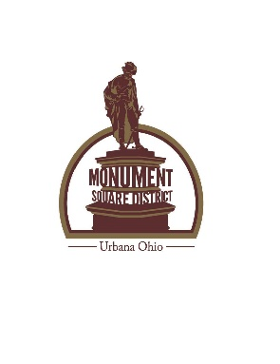
PARTNERSHIP AGREEMENT

It is hereby mutually agreed between the Monument Square District and
________________________________________________________________
Name Contact Phone

______________________________________________________________________
Address City State Zip

The parties have entered into this Partnership Agreement under the terms and conditions as set forth herein and in the Request Form, as set forth on Page 1 and incorporated by reference in this Partnership Agreement for the approved request during the dates/times indicated.
Organizational fees:
Legacy Park
$50.00 fee, waived if event is directly involving the downtown or additional space for an already scheduled event.
**Full payment must be received by Monument Square District prior to the event**

Temporary Liquor Permit fees:
________% of profit or a minimum of $_______
**Full payment must be received by Monument Square District within 10 days following the event**
Make checks payable to:
Monument Square District
P O Box 707
Urbana, OH 43078

___________________________________________________________________
User Event/Contact Person Date
Approved: ___________
Denied: _____________ Reason: ______________________________________
___________________________________________________________________
Monument Square District Board Representative Date:

